

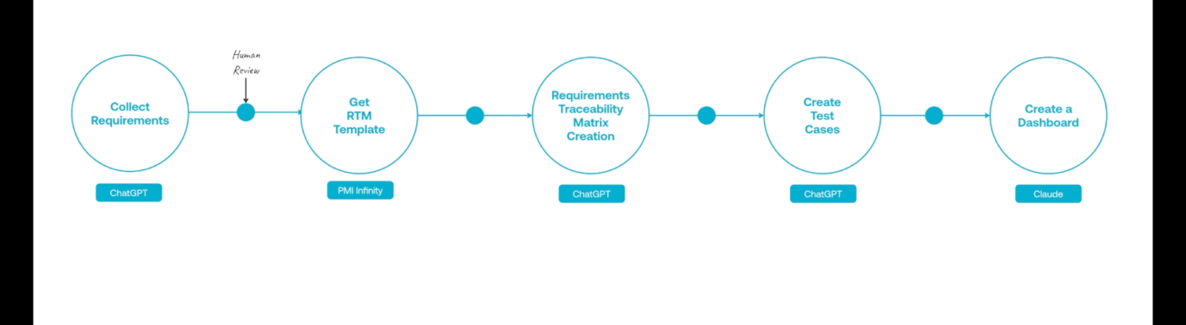

Collect Requirements
Prompt1:
You are an expert project manager, specializing in software development. I am providing documents, transcripts from stakeholder meetings, survey results and my project charter.
Review and analyze all the attached information that has been collected as part of the requirements gathering project management process. Then, make a list of all the project requirements present in this documentation and organize them according to requirement type.

- This gives a Project Requirements Analysis document.

Now we need a RTM template.

Get RTM Template
Prompt2
Provide a good Requirements traceability matrix for software development.

Requirements Traceability Matrix Creation
Prompt 3
Use all the information I provided and the PDF you created to organize the project requirements into a Requirements Traceability
Matrix. Please include the following information in the RTM:
• Requirement ID: A unique identifier for each requirement.
• Requirement Description: A brief description of the requirement.
• Source: The origin of the requirement, such as a Business Requirements Document (BRD).
• Priority: The importance of the requirement (e.g., High, Medium, Low).
• Design Specification: Reference to the design document that addresses the requirement.
• Development Status: Current status of the development (e.g., Not Started, In Progress, Completed).
• Test Case ID: Identifier for the test case that will validate the requirement.
• Test Status: Current status of the testing (e.g., Not Tested, Passed, Failed).
• Comments: Any additional notes or comments.

This RTM document is verified by team.

Create Test cases
Prompt4: Create user test case for these requirements and verify that the test cases matches our RTM.
Asking ai for suggestion: Prompt 5: what do you suggest i include in a dashboard created to monitor my RTM?
Then
Prompt 6: Please include them in the dashboard and create a html file so that i can host in github or somewhere

